TABLE OF CONTENTS

TABLE OF CONTENTS 1
TABLE OF FIGURES 2
PRODUCTION BOARD TEST PLAN 3
HOW TO DONWLOAD NECESSARY TOOLS 3
REQUIRED SOFTWARE TOOLS 3
REQUIRED HARDWARE TOOLS 3
HOW TO INSTALL THE TOOLS? 4
HARDWARE INSTALLATION 4
HOW TO USE THE TEST TOOLS 5
HOW CAN WE MAKE A TEST? 6
SETTING UP THE HARDWARE 6
HOW TO INSTALL AND CONFIGURE TWINCAT 7

TABLE OF FIGURES

Figure 1 Headers to interconnect Control Board and Interface Board 5
Figure 2 Image showing power input headers 5
Figure 3 On-board LED showing power state 5
Figure 4 Programming header and connections 6
Figure 5 Stepper motor connection headers 7
Figure 6 TwinCAT Start Page Menu View 8
Figure 7 Window showing compatible Ethernet Devices 8
Figure 8 Image showing driver successfully installed 9
Figure 9 Network settings properties option 9
Figure 10 Networking item view 9
Figure 11 TwinCat start page 10
Figure 12 TwinCat toolbar view 10
Figure 13 Solution explorer view 11
Figure 14 I/O device view 11
Figure 15 Scan for boxes pop-up 11
Figure 16 Device tab section view 12
Figure 17 Device properties tab 12
Figure 18 Device settings list 13
Figure 19 EEPROM update section 13
Figure 20 Twincat project view 14
Figure 21 Device tab section view 14
Figure 22 Twincat project view 15
Figure 23 Image showing option from where TwinCAT can be started in Run Mode 15
Figure 24 BIOS Menu in an HP System 16
Figure 25 Virtualization Technology (VTx) checkbox image 16
Figure 26 Screenshot showing location of Activate Configuration 17
Figure 27 Generate License Prompt Box 17
Figure 28 Screenshot showing login screen 17
Figure 29 Start button in TwinCAT 18
Figure 30 Main control window for testing firmware 18

PRODUCTION BOARD TEST PLAN

HOW TO DONWLOAD NECESSARY TOOLS
This section will cover the basic requirements from both software and hardware perspective which will allow us to power up the board, load the firmware and then test it.

REQUIRED SOFTWARE TOOLS
- J-Link Commander (Select 32-bit Installer or 64-bit Installer depending on your OS)
- J-Link serial port drivers (Although these are installed automatically upon plugging in, if not, please do a manual install)
- TwinCAT (For sending EtherCAT commands)

REQUIRED HARDWARE TOOLS
- Interface Board and Control Board PCBs
- Power Supply 24V, 3A
- J-Link Probe
- J-Link probe converter (will be provided by eSpark for easy firmware upload)
- Stepper Motor

HOW TO INSTALL THE TOOLS?

HARDWARE INSTALLATION
To install the hardware and make it ready for firmware upload, following steps are required:
- Connect Interface Board with Control Board using interconnect jumpers provided on both boards as shown below
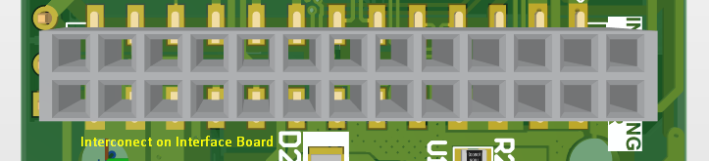
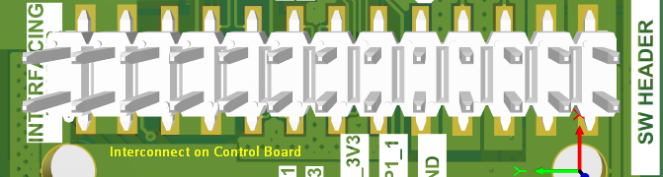
Figure 1 Headers to interconnect Control Board and Interface Board
- Power up the board using adequate power supply mentioned in specifications above. The power input is to be applied on the headers shown in image below:
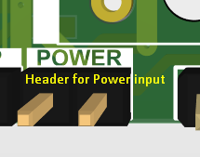
Figure 2 Image showing power input headers
- Once the board is successfully powered up, an on-board test LED on the Control Board will light up indicating successful power up as shown below

Figure 3 On-board LED showing power state
- Connect the provided J-link probe to the programming header as shown in the image below:
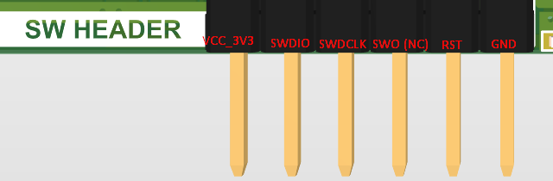
Figure 4 Programming header and connections
- Once the programming probe is connected, launch J-Link Commander and run the connect command and choose SWD interface with default settings.
- If the connection is successful, this means the processor is alive and working well.

HOW TO USE THE TEST TOOLS
- After successfully connecting with the hardware using J-Link Commander, upload the provided Final_Test.elf file which is the final compiled code file for the project. To do this, run the command:

LoadFile <FileName> [<Addr(.bin only)>] [<noreset | reset>]
loadfile <path\to\provided\elf\file> (Example)

- After successful upload, the J-Link Commander will show successfully loaded.

HOW CAN WE MAKE A TEST?

SETTING UP THE HARDWARE
In order to prepare a test, follow the steps below:
- Connect the stepper motor to the header labeled MOTOR OUT. Connections are also enlisted starting from left side:
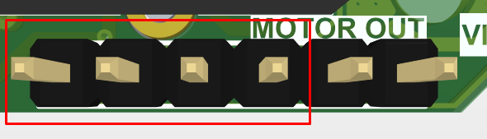
Figure 5 Stepper motor connection headers
  - MOTOR_A1 (Motor coil A1)
  - MOTOR_A2 (Motor coil A2)
  - MOTOR_B1 (Motor coil B1)
  - MOTOR_B2 (Motor coil B2)
- Once the connections are done, power up the board and connect the Ethernet cable from PC to the board.
- Observe the commands behavior of board on the TwinCAT software

HOW TO INSTALL AND CONFIGURE TWINCAT
- Run the installation file.
- The on-screen menu will guide with the installation process. Please note that we have to select Complete Installation option.
- Once the installation is complete, launch TwinCAT software and go to TwinCAT > Show Realtime Ethernet Compatible Devices…
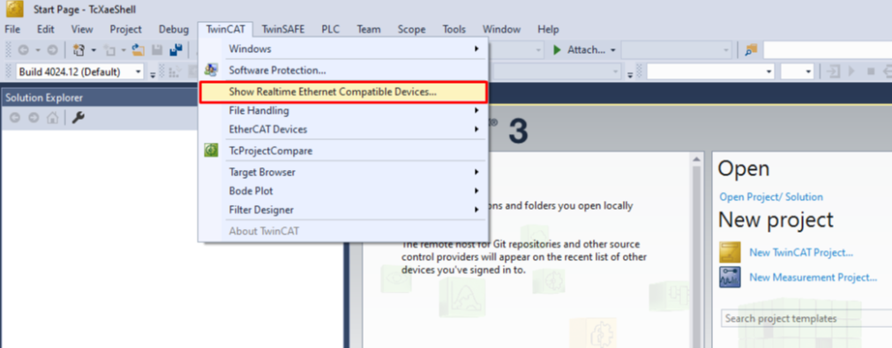
Figure 6 TwinCAT Start Page Menu View
- The following window will open. Select the driver as shown and click Install
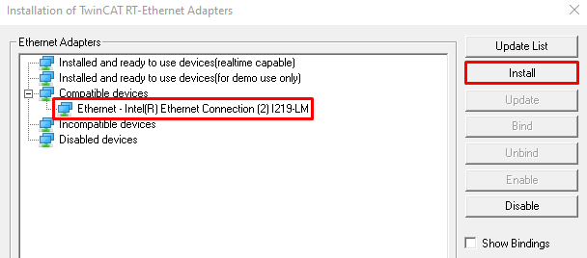
Figure 7 Window showing compatible Ethernet Devices
- Once the driver is successfully installed, it will appear under installed devices as shown below:
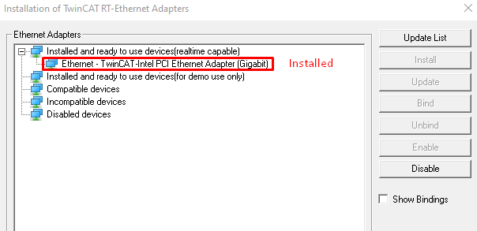
Figure 8 Image showing driver successfully installed
- After verifying in TwinCAT, go to Network Settings in computer and open Properties
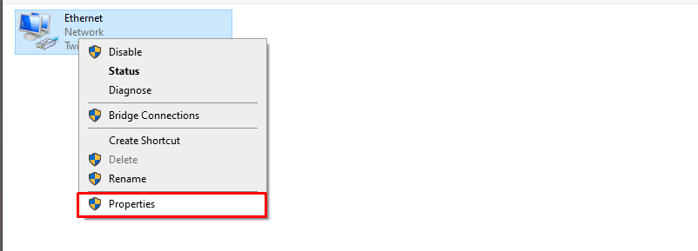
Figure 9 Network settings properties option
- Disable all the items and only allow TwinCAT Ethernet Protocol to remain enabled
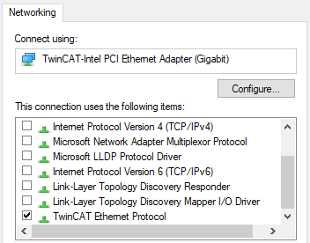
Figure 10 Networking item view

- Place the LAN9255.xml file in the following path
C:\TwinCAT\3.1\Config\Io\EtherCAT

- Create a new Project by clicking on New TwinCat Project.
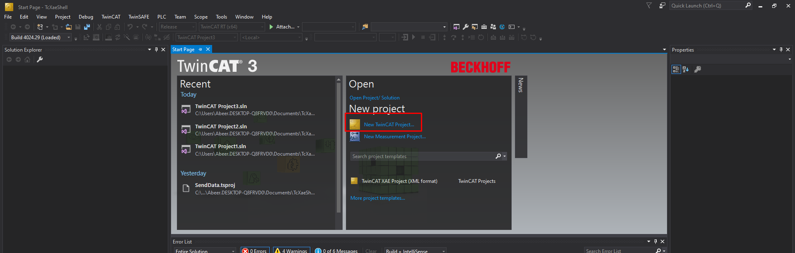
Figure 11 TwinCat start page

- Switch to config mode.
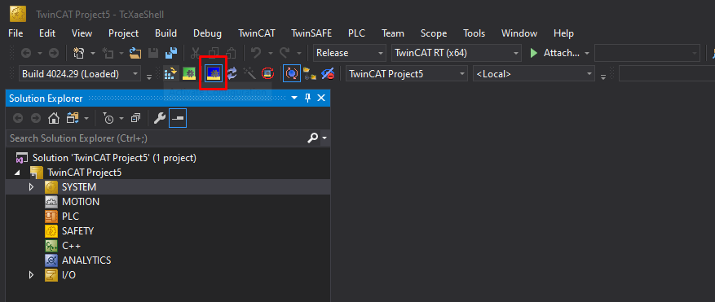
Figure 12 TwinCat toolbar view

- Make sure that the ethernet cable is connected to the Port A of the board then click on Scan.
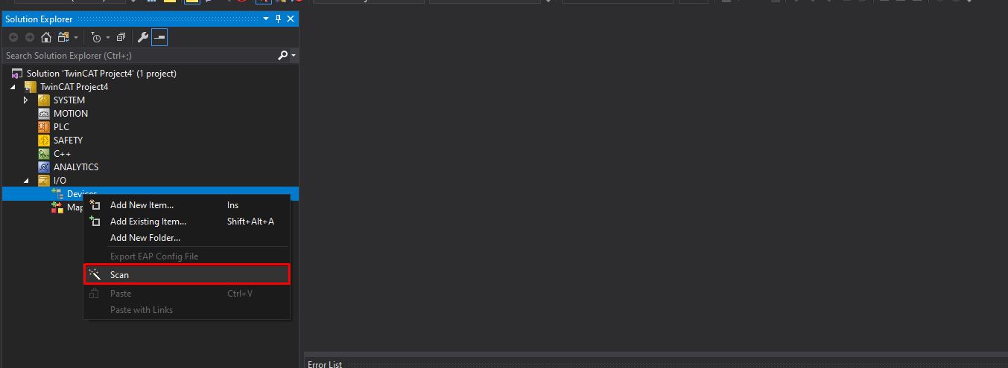
Figure 13 Solution explorer view
- The board will appear as Device 2. Click on OK.
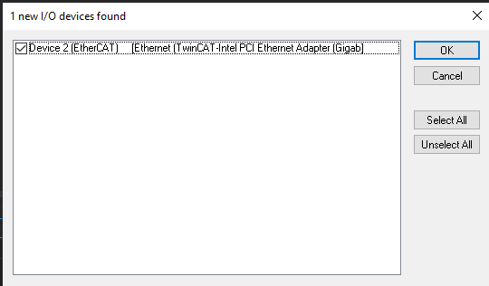
Figure 14 I/O device view
- Click Yes.
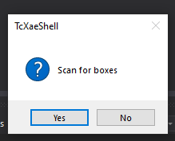
Figure 15 Scan for boxes pop-up

- Since the EEPROM is not there So the board will appear like this.
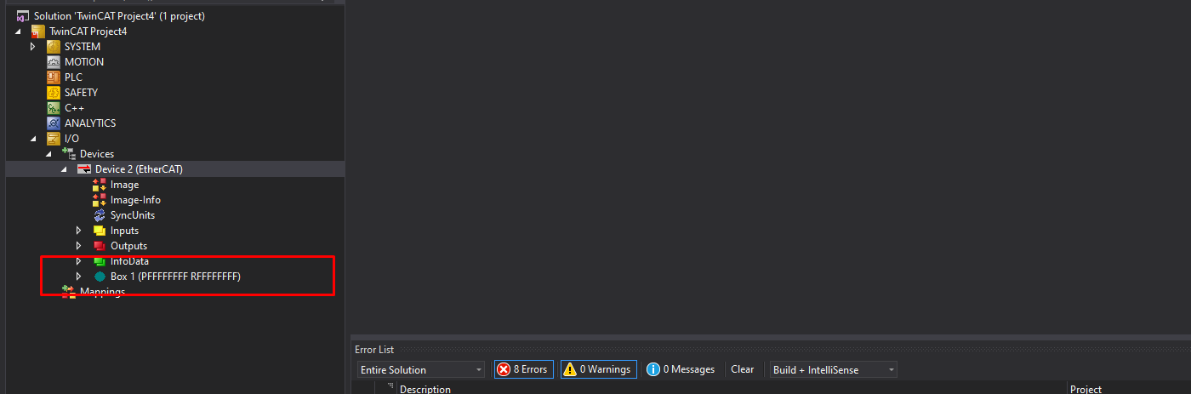
Figure 16 Device tab section view
- Navigate to Device 2 and the to the Online tab.
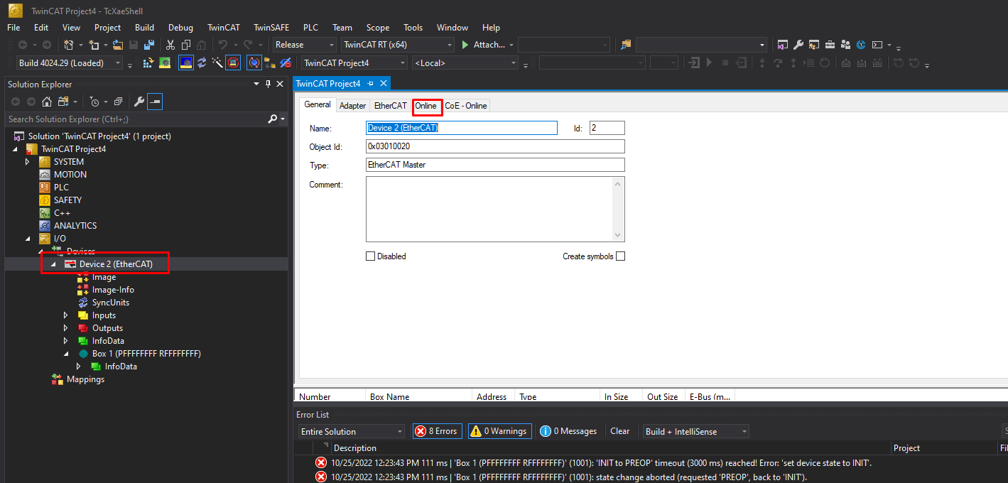
Figure 17 Device properties tab

- Right click on Box 1 and then select EEPROM Update.
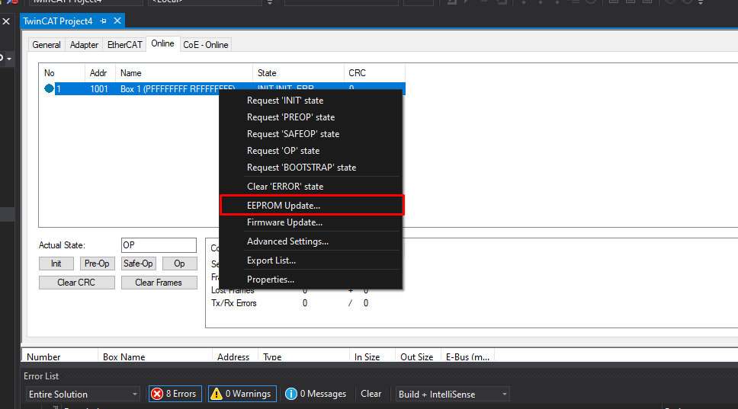
Figure 18 Device settings list
- Scroll down till you find Kurvatur A/S and then double click on sample_app to flash the EEPROM.
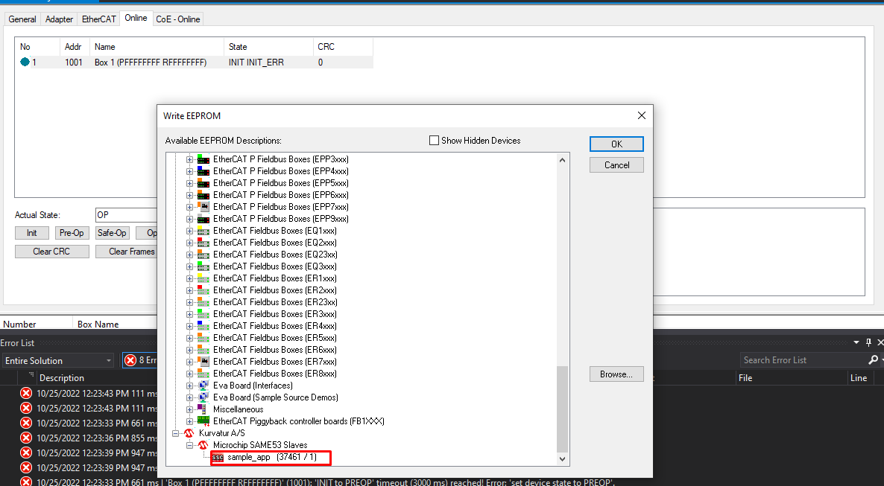
Figure 19 EEPROM update section

- The EEPROM is now flashing.
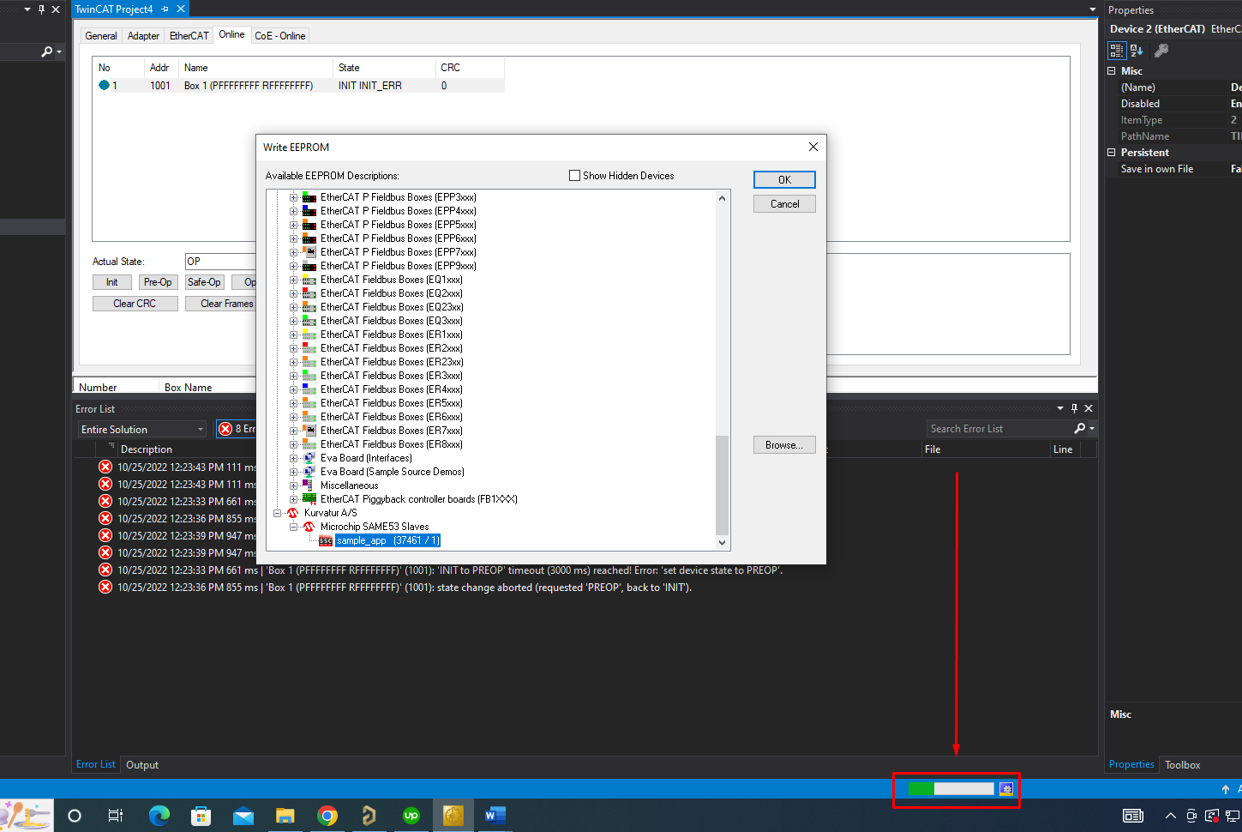
Figure 20 Twincat project view

- Once the flashing is done remove the device and then scan again.
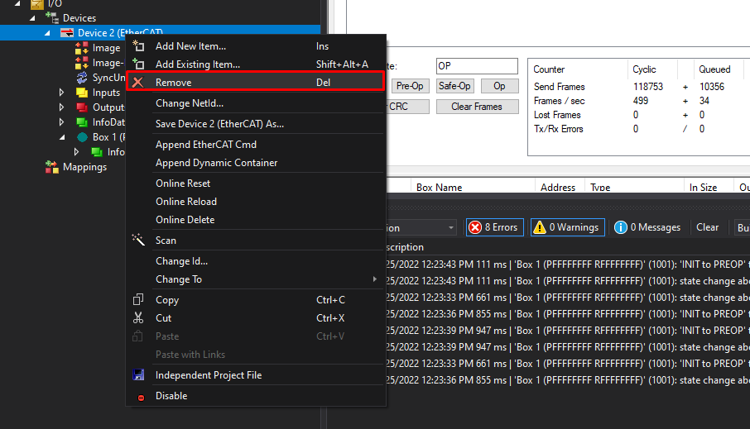
Figure 21 Device tab section view

- Box 1 will be displayed as sample_app now. EEPROM is flashed successfully.
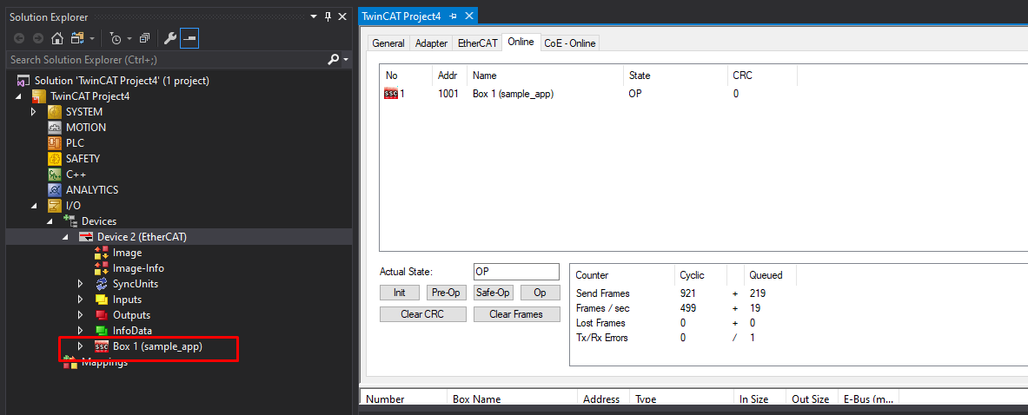
Figure 22 Twincat project view
- Open the provided SendData TwinCAT Project. The project file is located in the main folder as SendData.sln. Please make sure the project is opened using TwinCAT XAE Shell Software only.
- Once the project is opened, click the Restart TwinCAT System button as shown in the image below. This will restart TwinCAT in Run Mode.
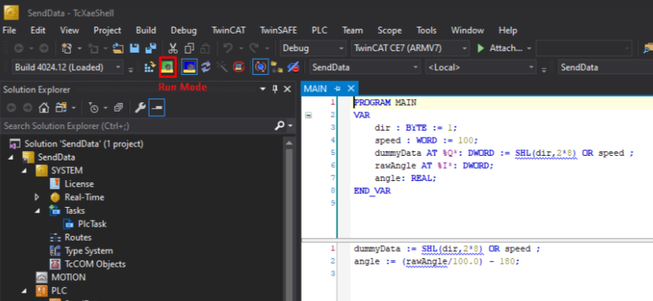
Figure 23 Image showing option from where TwinCAT can be started in Run Mode
- If the system responds with following two errors, this means vt-x is disabled and has to be enabled from BIOS.
- The setup assumes an HP System for explaining how to enter and enable vt-x (virtualization) from BIOS. When the computer restarts, press ESCAPE key to enter BIOS Menu.

- Once inside the menu, the following options will appear:
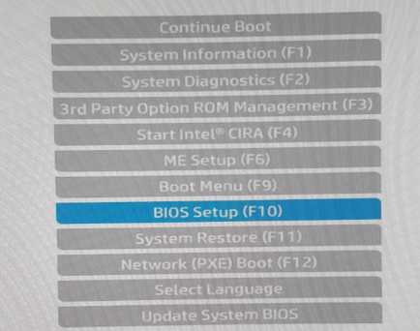
Figure 24 BIOS Menu in an HP System
- Go to Advanced > System Options and enable Virtualization Technology (VTx).
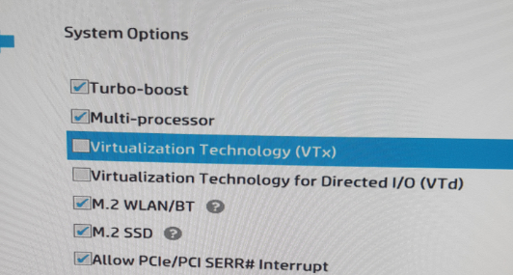
Figure 25 Virtualization Technology (VTx) checkbox image
- After this, when windows opens, Go to C:\TwinCAT\3.1\System and find win8settick.bat. Run is as Administrator and reboot the machine.

- When PC restarts again, launch TwinCAT XAE Shell and click on Activate Configuration as shown in the image below:
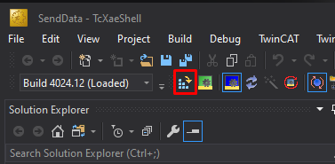
Figure 26 Screenshot showing location of Activate Configuration
- A prompt will appear asking for generation of licenses. Click Yes to proceed.
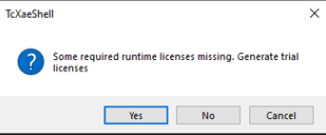
Figure 27 Generate License Prompt Box
- Enter Security Code and press O.K. to proceed. After this, place the shared configuration file LAN9255.xml at following location C:\TwinCAT\3.1\Config\Io\EtherCAT
- After file placement, restart TwinCAT XAE Shell and repeat Step 9. After TwinCAT restarts, click Login as shown:
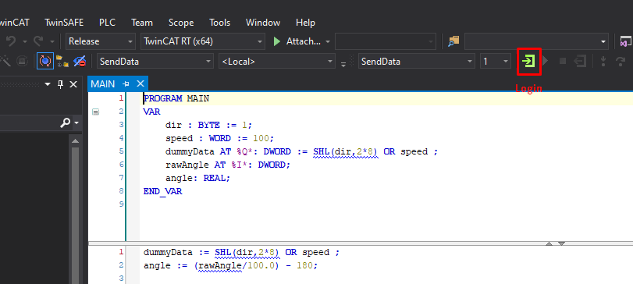
Figure 28 Screenshot showing login screen
- After that, click Start button.
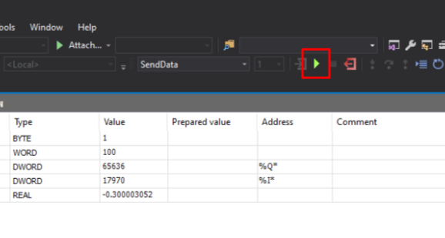
Figure 29 Start button in TwinCAT
- Now you can control speed and direction by preparing it for another value and then write the values and simultaneously receive motor position in the angle variable
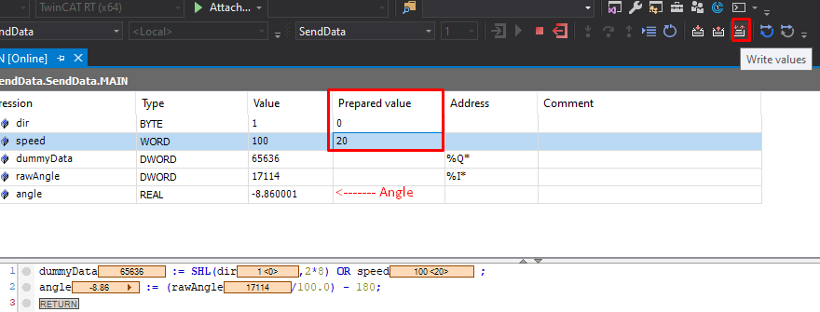Figure 30 Main control window for testing firmware

